PART 1: PROJECT METADATA

General Project Information
Project ID (number) | Project Title
2405 | Biological models to support prioritizing salmon stocks under future climates
Project Leads | Collaborations and External Partners
Jan Finke  Travis Tai  Brendan Connors  Cameron Freshwater  Patrick Thompson | Amber Holdsworth and Angelica Pena (Ocean Sciences Division); Dan Selbie, Howard Stiff, Greig Oldford, and Josie Iacarella (Ecosystem Science Division)
Location (if applicable)
Click or tap here to enter text.

Geographic and Stock Information
Salmon species (if applicable) | Waterbodies (if applicable)
Sockeye Salmon | NA
Life history phases (if applicable) | Region
Lifecycle: Spawners, smolts, escapement | British Columbia and Washington
Stock (if applicable) | Population (if applicable)
Click or tap here to enter text. | Click or tap here to enter text.
Conservation Unit (if applicable)
Click or tap here to enter text.

🧰 PART 2: PROJECT METRICS
List scientific publications and technical reports (with links)
- Primary publication presenting model and estimates of how environmental conditions in different parts of the life cycle impact productivity and survival in 13 populations across the region. This will include projections of how the populations are likely to respond to changes in climate over the coming decades (in progress – draft by end of March 2026 with submission in early 2026-27 fiscal year).
List datasets generated (with links)
N/A
Describe dataset locations and data management systems
All code and data used to produce the model and figures will be posted on Github with static Zendo link.
List code, programs, or other software created (with links)
All model code available here - https://github.com/SiRE-P/PSSI_salmon_climate (currently requires permission to access, will be made public when the paper is published)
List communication or social media products
- PowerPoint presentation given at PSSI symposium (December 2025) - Insights into the effects of marine and freshwater variables on sockeye salmon population dynamics: A hierarchical lifecycle approach
List and describe field work completed
N/A
List and describe samples collected/analyzed (number of samples)
N/A
List and describe large capital assets or equipment acquired
N/A

PART 3: WRITTEN CONTENT
- The goal of the project is to estimate how climate related environmental variables are influencing sockeye salmon productivity across different life stages and populations using quantitative models. These estimates will be combined with climate projections to estimate how future conditions may impact salmon populations in future decades.
- Key initial findings, based on the 13 populations model:
  - Environmental drivers and life stages influencing future impacts vary among populations.
  - All assessed populations are sensitive to projected changes
  - Negative impacts are expected to be greatest in southern regions (Columbia, Fraser, WCVI) and driven by increased marine temperatures and freshwater temperatures during adult migrations, while some northern populations may initially benefit from warming.

- These projections will help identify the life stages most vulnerable to climate change and guide management strategies by highlighting population-specific sensitivities.

🌐Background
Many sockeye salmon populations have declined in abundance despite reductions in harvest, suggesting reduced productivity driven by environmental forcing, with poor marine survival identified as a key contributing factor (Peterman and Dorner 2012, Connors et al. 2020). Yet some sockeye salmon populations are stable or increasing (Brown et al. in press, Ogden et al. 2024). The cause of divergent trends in abundance is unclear, resulting in considerable uncertainty about which sockeye salmon populations are most likely to be resilient to changing environmental conditions.

Evaluating future risk requires information on both population-specific stressors and biological responses to those stressors. Although quantitative climate change vulnerability assessments have been performed for a number of Pacific salmon populations, they have largely focused on American Chinook salmon populations from a small number of watersheds (e.g. Crozier et al. 2021). Here we leveraged a unique dataset of juvenile and adult abundance from a network of thirteen sockeye salmon populations extending from the Columbia River to northern British Columbia. We parameterized an age-structured life cycle model that included freshwater and marine covariates to estimate population-specific functional responses, then evaluated how populations fared under various climate change scenarios. Our study incorporated expertise from diverse collaborators, within and outside DFO, with expertise in stock assessment, global climate models, and salmon ecology. Our work can be used to identify Pacific salmon life stages that are most vulnerable to climate change and help prioritize management interventions.

️ Methods and Findings
Please insert a few paragraphs to summarize:
- Main methods used
- Products and tools produced
- Advancements in methodology, technology, and application
- Advancements in communication and knowledge transfer
- Key results and information generated
Overview of the model
We developed a full life cycle model that consists of two stages: 1) spawner to smolt production and 2) smolt to adult recruit survival (Figure 1). Each stage of the model consists of a Beverton-Holt function, where density-independent production (i.e., survival) is a function of the environmental conditions experienced in that life stage. We modelled each age class separately because sockeye salmon vary in the number of years that they spend rearing in freshwater as well as in the ocean, and covariates were lagged so that each age class was only affected when it overlapped in space and time with a given covariate.

We used a state space approach that linked population dynamics to the observed data and accounted for cyclical feedback among generations. This structure allowed us to account for missing data, observation error, and variation in the life stage that was observed for juveniles (smolt vs. fry). The model was implemented in Stan and fit using Bayesian inference within a hierarchical framework, allowing information to be shared across populations.

Salmon data
Our model is based on thirteen populations of sockeye salmon (Figure 2) where there are estimates of spawner abundance, juvenile abundance (smolt or fry), and adult recruitment. In addition, we have estimates of age structure for juveniles, adult recruits, or both. These populations come from six different watersheds spanning the entire province of BC: Columbia, Somass, Fraser, Skeena, Stikine, Taku. We included data from 1981 to 2024 in our model.

Environmental covariates
We selected environmental covariates based on our understanding of the sockeye salmon lifecycle and when and where the populations experience different conditions. To do this, we developed a directed acyclic graph (DAG; simplified version in Figure 2) that outlines our hypothesized causal effects, as well as our understanding of how environmental covariates influence each other or are influenced by shared drivers (e.g., a common regional climate). We were unable to include all hypothesized covariates, because in many cases we do not have appropriate data for all populations. For example, we know that zooplankton community composition is likely to influence survival (Peterson and Schwing 2003) and that zooplankton dynamics are in turn influenced by temperature and mixed layer depth (Mackas et al. 2012). Thus, based on our model structure, we can interpret any effects of marine temperature and mixed layer depth as being, at least partially due to their effects on zooplankton. In this way, we use the DAG to understand whether our estimated environmental effects are likely to be biased or confounded, and to adjust our model and interpretation accordingly.
The environmental covariates (Figure 3) that we hypothesized could influence spawner to smolt production were: 1) winter (Oct. to Mar.) rearing temperatures (2 or 3 years after spawning), and summer (Apr. to Sep.) rearing temperatures (1 or 2 years after spawning) in nursery lakes. The environmental covariates that may influence smolt to adult recruit survival were: 1) near surface temperature averaged across the juvenile marine migration route for the period of April to June; 2) mixed layer depth averaged across the juvenile marine migration route for the period of April to June; 3) near surface temperatures in the open ocean in summer (Jul. to Sep., 1 or 2 years after ocean entry) and winter (Jan. - Mar.; 1,2, or 3 years after ocean entry); 4) river temperature during upstream migration , 5) river discharge during upstream migration.

Freshwater temperatures and discharge were sourced from the Pacific Climate Impact Consortium (Werner et al. 2019). The juvenile marine migration route is defined as all polygons in Figure 2 from the point of ocean entry for each population and north to Alaska along the continental shelf (i.e., depths less than 500 m). The open-ocean domain was defined by a rectangular polygon in the North Pacific, bounded by 170°W, 145°W, 60°N, and 45°N; areas shallower than 1000 m and regions north of the Aleutian Islands were excluded. Coastal temperature and mixed layer depth were sourced from the BCCM downscaled climate model (Peña and Fine 2024), the HOTSsea model (Oldford et al. 2024) and the GLORYS12 reanalysis (E.U. Copernicus Marine Service Information (CMEMS). Marine Data Store (MDS)). Open ocean temperatures were sourced from GLORYS12.

Future projections
We are still in the process of integrating our model with future climate projections.
This will be done by taking the estimated parameters of our model and applying them to averaged historical (1995 to 2025) baseline conditions as well as future projected (2041 to 2070) environmental conditions. This will allow us to estimate how the mean number of adult recruits per spawner is expected to change between these two periods, due to climate change. We plan to contrast the RCP 4.5 and 8.5 future climate scenarios to assess how sensitive our projections are to the specific emission scenario. Future climate projections will be sourced from the BCCM (Pena et al.) model, downscaled CMIP6 model (ACTEA) and PCIC (citation).

Initial results
We find that all populations are sensitive to environmental change at some point in the lifecycle (Figure 4). However, there is considerable variation across populations as to where in the lifecycle environmental conditions have the greatest impact. Southern populations (WCVI and Columbia) appear to be most sensitive to changes in the early marine stage. Fraser and Columbia populations appear to be most sensitive to warm waters experienced during upstream migration. In contrast, summer temperatures during lake residence had a relatively small effect on recruitment for all populations. Northern populations show greater variability in their responses, and some may even benefit from some degree of warming.

💡Insights
Although we are still integrating our population model with future climate projections, our preliminary results highlight striking similarities and differences among sockeye salmon populations that are relevant to management. The majority of populations showed marked declines in abundance as marine and freshwater temperatures increase. Yet the life stages and environmental drivers regulating future impacts varied among populations. These patterns suggest management interventions will be most effective if they are applied in a regional or population-specific context and target life stages that have the greatest impact on subsequent recruitment.

More broadly, our findings emphasize the value of leveraging life cycle models when evaluating climate change risk. Climate change vulnerability assessments often rely on predicted changes in putative stressors, rather than population level responses to those stressors. Such frameworks implicitly assume that populations respond similarly to, for example, one degree of warming. Furthermore, without clear linkages to a biological response, it is often challenging to evaluate the relative impact of stressors in different spatial domains (e.g., freshwater vs. marine temperatures) or representing different physical processes (e.g., changes in temperature vs. flow). Although qualitative approaches are necessary in data limited scenarios, uncertainties should be clearly communicated to decision makers.

Despite its complexity, our model only incorporated abundance data from three life stages, limiting our ability to precisely link indicators to biological responses. Marine spatiotemporal distributions are also relatively poorly resolved, particularly for more data-limited northern populations and for all populations during offshore residence. Both of these factors will increase the uncertainty associated with effect size estimates. Additionally, we could only incorporate indicators that were readily available in historical time series and climate projections, and we assumed that ecological responses to environmental drivers would remain constant in the future. Such assumptions are necessary in correlative models where the mechanisms linking, for example, temperature to survival remain unknown, but may lead to biased estimates of life stage-specific effects. Given the complexity of ecological systems (e.g., non-stationarity; Litzow et al. 2019), our predictions should be viewed cautiously and revised as additional data become available.

⏩ Next Steps
Our project focused on developing the hierarchical Bayesian model and applying it to thirteen populations with high quality data. Our goal was to estimate the effects of climate-related environmental covariates and make projections of future abundance. Now that this has been done, there are a number of ways that the model could be extended to address key knowledge gaps for DFO.
1) extending to data limited populations – the hierarchical state-space structure of our model means that it should be possible to include populations where we lack juvenile abundance estimates. The model would leverage information from data rich populations to allow us to make inference about more data limited populations. Because DFO only surveys juvenile abundance for a minority of populations, this would allow us to include many more populations. This would greatly increase the ability for managers to use this information to consider climate impacts on sockeye stocks across the region.

2) exploring harvest scenarios under future climates – our model includes the proportion of the recruits that were harvested each year. This means that it would be possible to make projections under different harvest rates to explore the interaction between harvest management decisions and climate change.

3) assessing the benefits of stage specific life-cycle modelling vs. traditional spawner recruitment models – our model estimates could be contrasted against those from a simplified version that only includes spawners and recruits to quantify how the inclusion of the juvenile data improves our ability to estimate the causal effects of the environmental covariates. This analysis would also provide information on the magnitude of bias, if any, in previous analyses that drew inference on environmental effects using only spawner and recruit data.

4) assess how much recruitment variation is explained by our environmental covariates – traditional stock assessment methods often do not incorporate environmental covariates, relying on the abundance of spawners to predict recruitment. Our model could be used to quantify how including environmental covariates may improve our ability to explain interannual variation in recruitment.

5) extending to other Pacific salmon species – the lifecycle structure in our model is specific to sockeye, but it could be adapted to model other species of Pacific salmon. Species with a mix of data-rich and data-limited populations may be most tractable.

6) incorporating additional environmental and salmon abundance variables - model development and refinement indicated that additional environmental variables that are available in historic and projected data could contribute to a further refined model. These include surface wind influencing lake and coastal mixing regimes, related primary production in coastal waters and snowpack coverage in watersheds. Similarly additional time series of salmon abundance (e.g., from juvenile freshwater or marine surveys) could be used to increase the ecological resolution of the life cycle model.

These extensions would support DFO’s implementation of Ecosystem Approach to Fisheries Management. Specifically, they would demonstrate the value of life-cycle modelling, including environmental covariates, and would allow us to link our findings to Fisheries Management by incorporating harvest decision rules.

📈 Tables and Figures
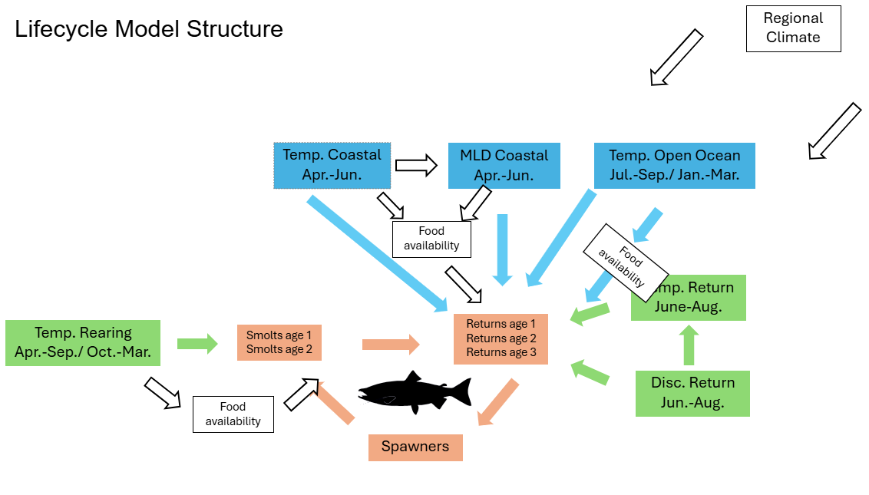Figure 1. Directed acyclic graph of the lifecycle model linking environmental covariates to salmon productivity and survival. Orange boxes represent life stages; green boxes, freshwater covariates; blue boxes, marine covariates; and white boxes, unobserved variables that may introduce correlations requiring adjustment for causal inference.

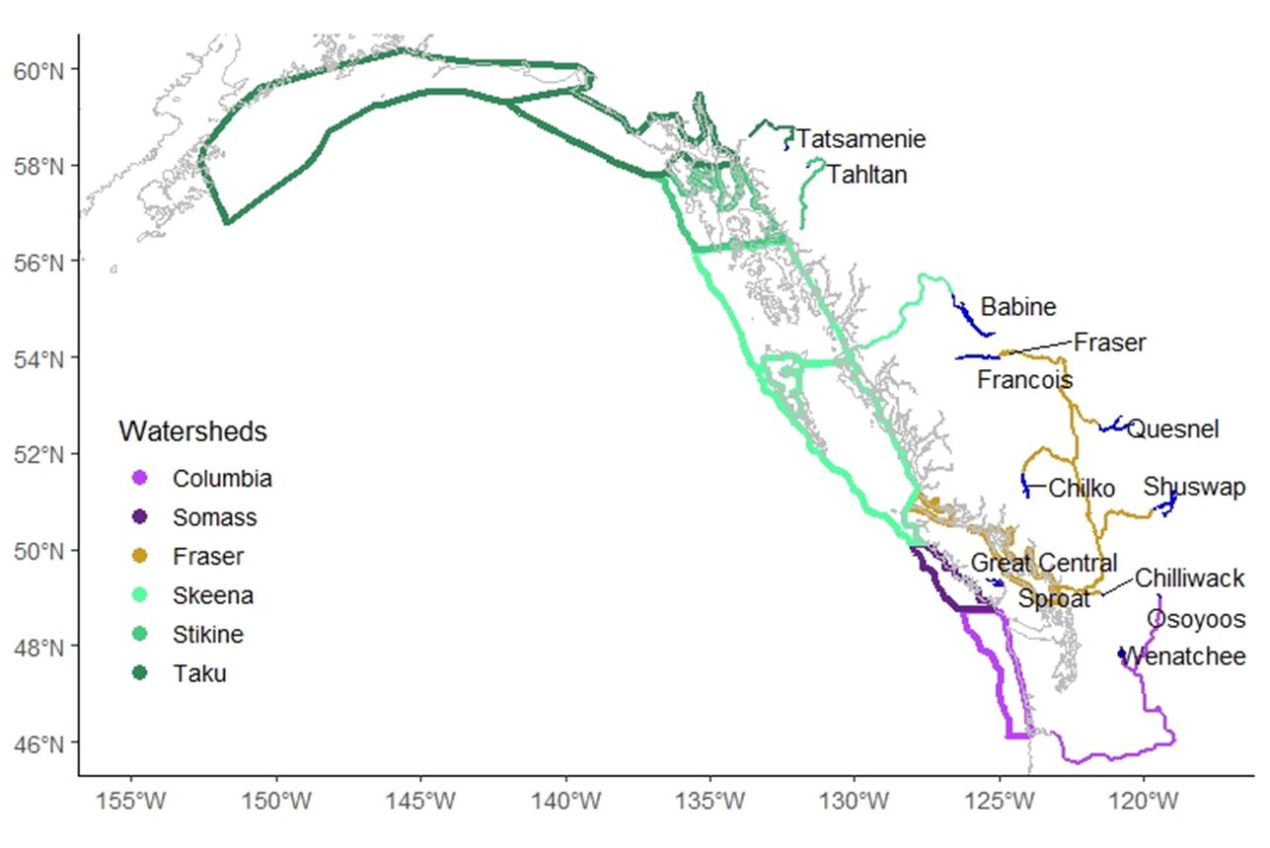Figure 2. Map of the populations included in the model. This includes the rearing lakes, the rivers, and the polygons that define the coastal shelf migration in the first marine summer. Open ocean domain (not shown) is shared among all populations.

Figure 3. Heat maps of environmental covariates used in the lifecycle model. Red indicates higher values and blue indicates lower values. All time series were standardized to allow direct comparison. Each panel represents one environmental variable, with rows showing different sockeye populations (freshwater variables), watersheds (coastal shelf variables), or the shared open ocean conditions (shared by all populations). MLD represents mixed layer depth on the coastal shelf.

Figure 4. Estimated percent change in returns per spawner for each population in response to a shift of 3 standard deviations (–1.5 to +1.5 SD), calculated relative to the range observed for that population. All other variables were held at their mean, so these represent marginal effects. This analysis highlights the sensitivity of each population to individual environmental drivers.

📈 References
Brown, N., Stiff, H., Bendriem, N., Luedke, W., Gibeau, P., Bocking, R., Lane, J., McHugh, D., Cunningham, D., Murrell, G., LaFlamme, J., Dobson, D. In press. Barkley Sound lake-type sockeye salmon (Oncorhynchus nerka) stock assessment in 2025. Can. Sci. Adv. Sec. Res. Doc.

Connors, B.C., Malick, M.J., Ruggerone, G.T., Rand, P., Adkison, M., Irvine, J.R., Campbell, R., Gorman, K. 2020. Climate and competition influence sockeye salmon population dynamics across the Northeast Pacific Ocean. Can. J. Fish. Aquat. Sci. 77: 943-949.

Crozier, L.C., Burke, B.J., Chasco, B.E., Widener, D.L., Zabel, R.W. 2021. Climate change threatens Chinook salmon throughout their life cycle. Comm. Biol. 4:222.

Litzow, M.A., Ciannelli, L., Cunningham, C.J., Johnson, B., Puerta, P. 2019. Nonstationary effects of ocean temperature on Pacific salmon productivity. Can. J. Fish. Aquat. Sci. 76: 1923-1928.

Mackas, D.L., Greve, W., Edwards, M., Chiba, S., Tadokoro, K., Eloire, D., Mazzocchi, M.G., Batten, S., Richardson, A.J., Johnson, C., Head, E., Conversi, A., Peluso, T. 2012. Changing zooplankton seasonality in a changing ocean: Comparing time series of zooplankton phenology. Prog. Ocean. 97-100: 31-62.

Ogden, A. Alex, K., Pestal, G., Alameddine, I., Davis, B., Judson, B., Stiff, H., Pham, S. 2025. Wild Salmon Policy status, limit reference point, and candidate escapement goals for Okanagan sockeye salmon. Can. Sci. Adv. Sec. Res. Doc. 2025/046: 102 p.

Oldford, G., Jarnikova, T., Christensen, V., Dunphy, M. 2024. HOTSSea v1: a NEMO-based physical hindcast of the Salish Sea (1980-2018) supporting ecosystem model development. Geosci. Model Dev. 18: 211-237.

Peña, M.A., Fine, I. 2024. Future Physical and Biogeochemical Ocean Conditions under Climate Change along the British Columbia Continental Margin. Atmosphere-Ocean. 62:2-23.

Peterman, R.M., Dorner, B. 2012. A widespread decrease in productivity of sockeye salmon (Oncorhynchus nerka) populations in western North America. Can. J. Fish. Aquat. Sci. 69: 1255-1260.
Peterson, W.T., Schwing, F.B. 2003. A new climate regime in northeast Pacific ecosystems. Geo. Res. Lett. 30: 1896.

Werner, A.T., Schnorbus, M.A., Shrestha, R.R., Cannon, A.J., Zwiers, F.W., Dayon G. Anslow, F. 2019. A long-term, temporally consistent, gridded daily meteorological dataset for northwestern North America, Scientific Data, 6:180299.

